Practical No.6: Implementing Clustering with Weka

Introduction
If data is not labeled then we can analyze this data by performing a clustering analysis, where clustering refers to the task of grouping a set of objects into classes of similar objects.

In this practical, we will apply clustering on Fisher’s Iris dataset. We will use clustering algorithms
to group flower samples into clusters with similar flower dimensions.

These clusters then become possible ways to group flowers samples into species. We will implement a simple k-means algorithm to cluster numerical attributes with the help of Weka and R.

In clustering, we know the attributes for the instances, but we don’t know the classes.

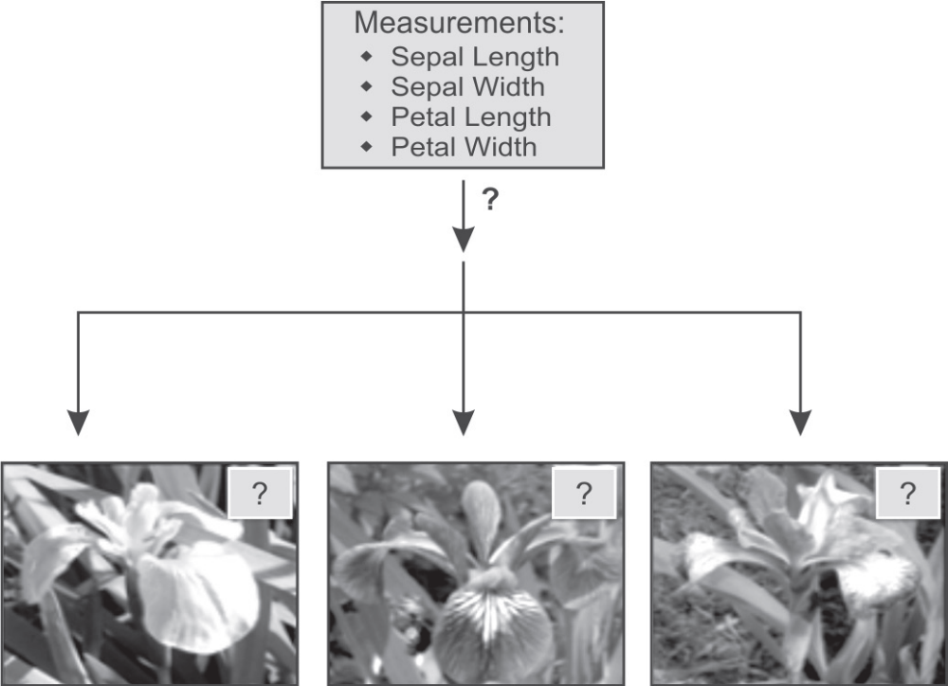
Fisher’s Iris dataset is already labeled, we will first make this dataset unlabeled by removing the class attribute, i.e., the species column. Then, we will apply clustering algorithms to cluster this data on the basis of its input attributes, i.e., Sepal length, Sepal width, Petal length, and Petal width.

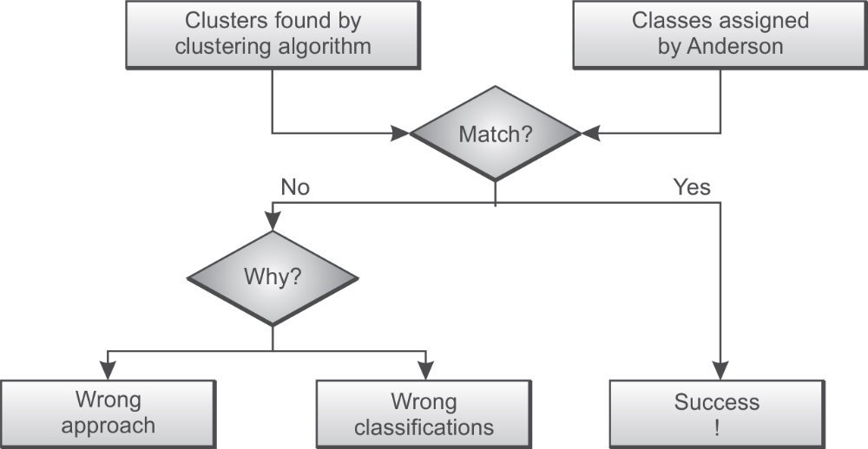

Clustering Fisher’s Iris Dataset with the Simple k-Means Algorithm
apply clustering on Fisher’s Iris dataset using Weka’s simple k-means algorithm. Since, Fisher’s
Iris dataset consists of samples belonging to three different species in the dataset, we will specify
numClusters to be three. To help us interpret results, we’ll set display StdDevs to true so that we can see the standard deviations for the instance cluster assignments as shown in Figure
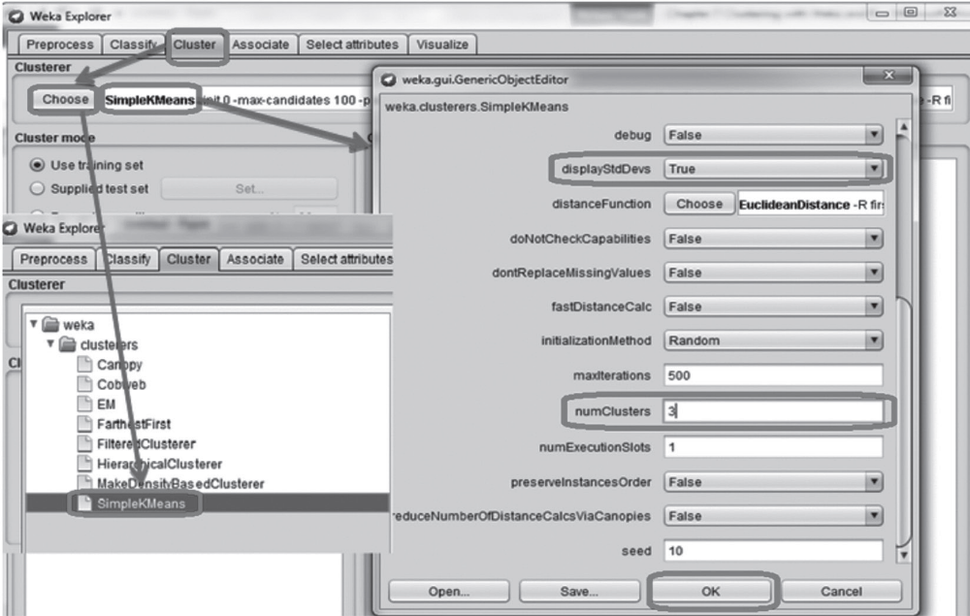
for clustering, data should be unlabeled, so let us ignore the label attribute, i.e.,
the Species class attribute during application of the clustering algorithm, by using Ignore attributes
and selecting Class in the Select items dialogue box as shown in Figure
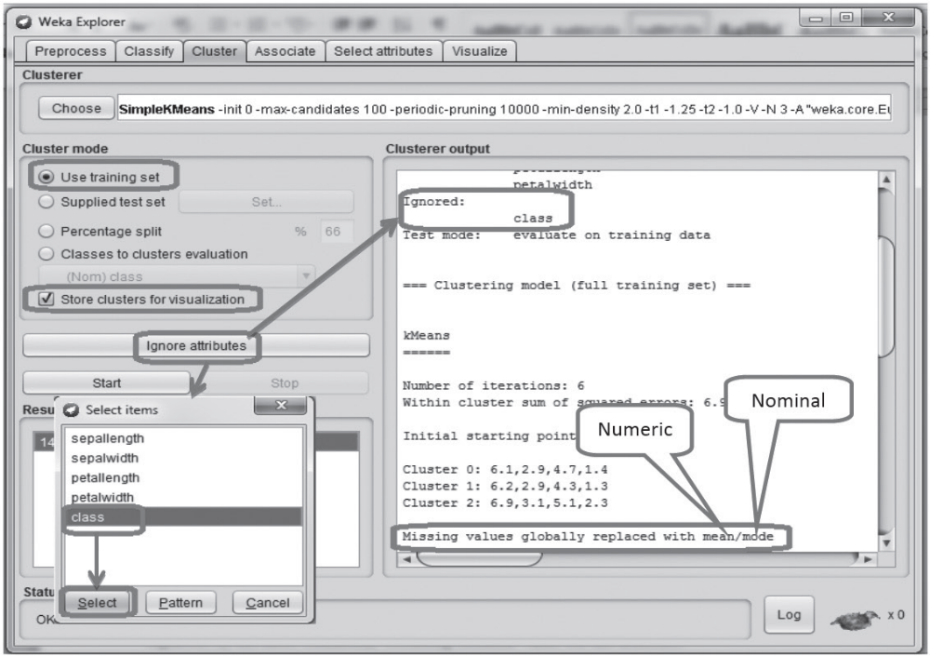

After applying the simple k-means clustering algorithm, we see the centroids of the three clusters and standard deviations for the sample values in each cluster as shown in Figure 8.6. For the results, we can verify that the k-means clustering algorithm identifies three clusters of data having 61 instances in first cluster, 50 instances in second cluster and 39 instances in third cluster.

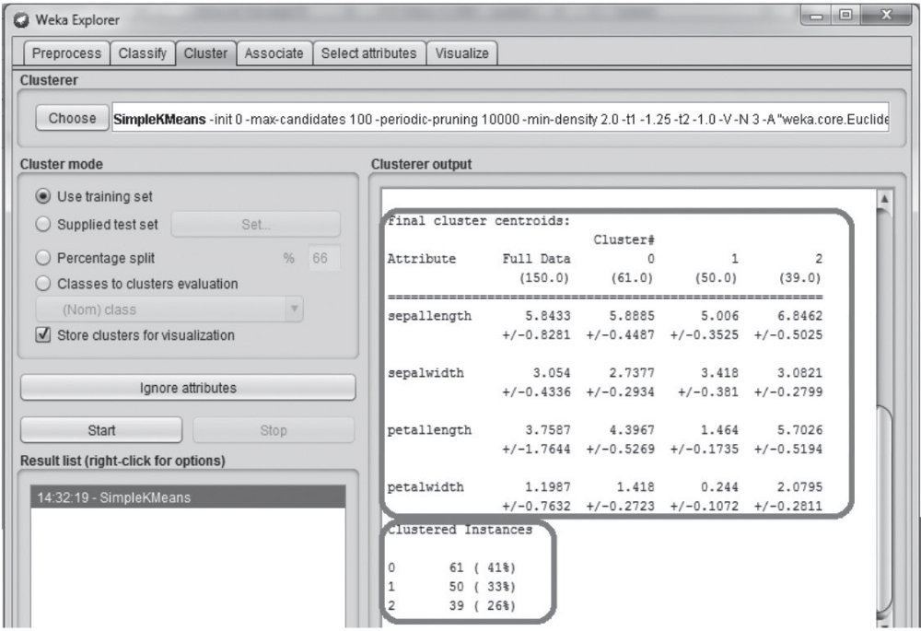
To compare the results given by the clustering algorithm with the actual clusters, we select the
Classes to cluster evaluation in cluster mode and re-run the clustering algorithm as shown in Figure
8.7. Using this, we can get more information on where Weka put each Iris sample.
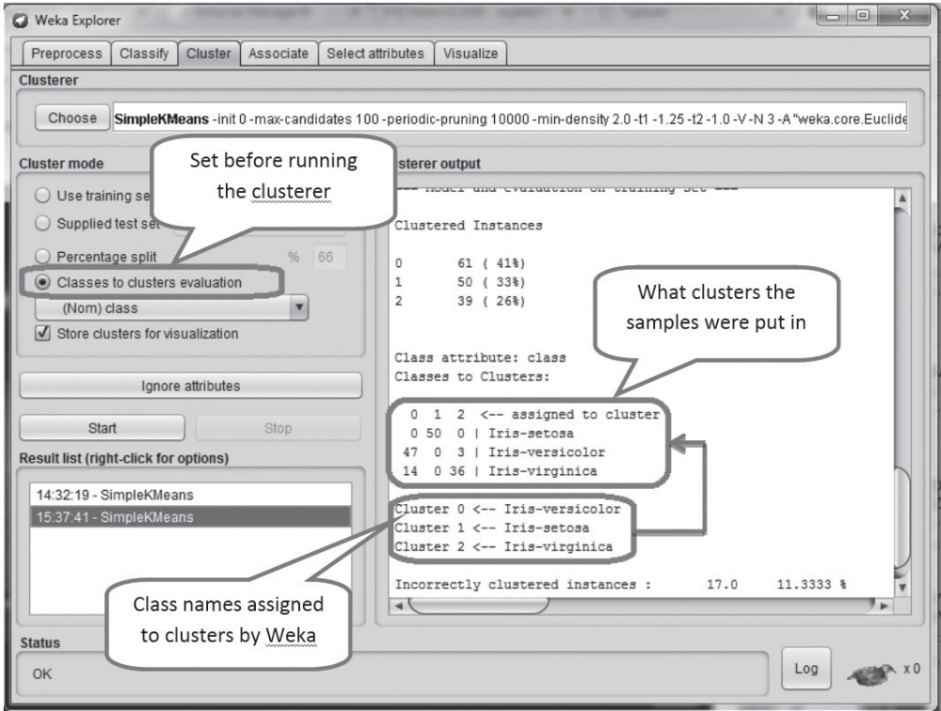
The clusters assigned by the clustering algorithm can be visualized across any of the input
attributes. For example, Figure 8.8 shows the visualization of clusters along with the plot axis selected as Petal length and Petal width. Jitter may be increased to see all the samples.
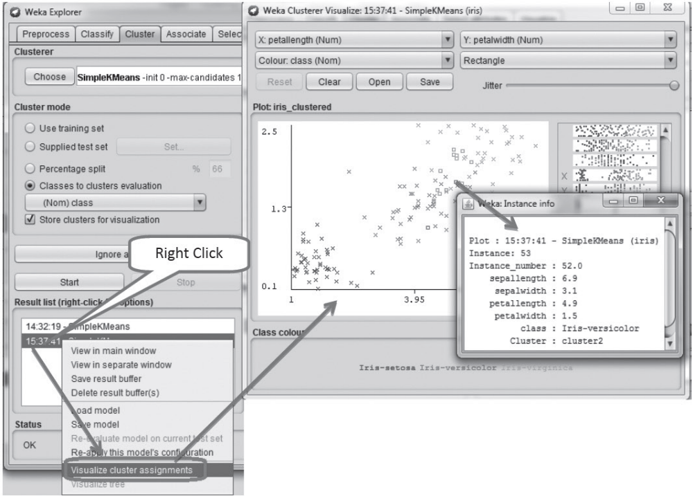

Through visual examination, it can be analyzed that some of the Versicolor instances that have been identified in the Virginica cluster, while it appears that on the basis of their Petal length vs. Petal width, they should be identified differently. And similarly, there are some Verginica instances identified as Versicolor while it appears that on the basis of the plot of Petal length vs. Petal width, they should be identified differently.

Through visual examination shown in Figure 8.10, we have drawn boundaries which seems to
separate the three species pretty reliably, based on just two of these attributes, i.e., Petal length and
Petal width. Consider the example of sample 50 that is classed as Versicolor by Anderson, and lies
on the Versicolor side of the species boundary. Therefore, the clustering algorithm should have put
this sample in the Versicolor cluster. But the simple k-means put this sample in the Virginica cluster
as shown in Figure

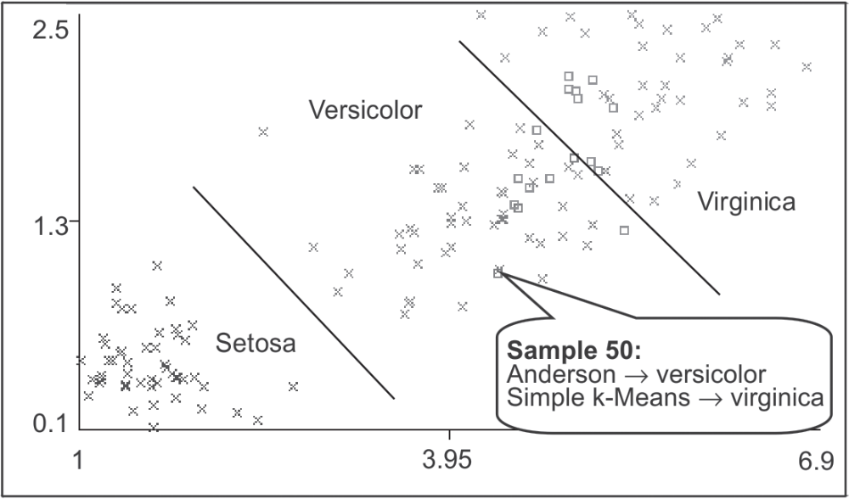
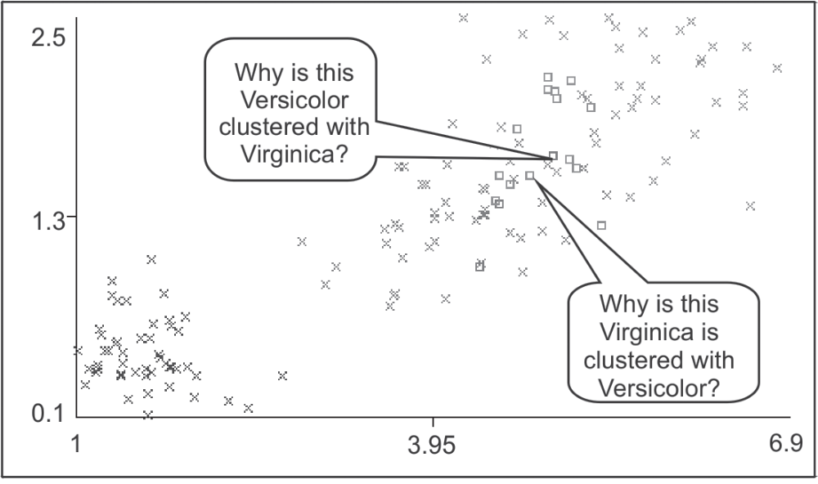

Identification of centroids for each cluster
